**Year 8 – Humanities and Social Sciences**

Task 2 – History Inquiry: A Significant Individual from the Medieval Period

Name: ______________________________________

Date Due: ___________________________________

|  |  |
| --- | --- |
| **Part A: Inquiry Process** | **Weighting (4%)** |
| **Part B:**  **Museum Display** | **Weighting (3.5%)** |
| **Part C: In-class validation** | **Weighting (2.5%)** |

**Part A: Inquiry Process – 52 Marks**

*Investigate the life of a significant individual in The Middle (Medieval) Ages*

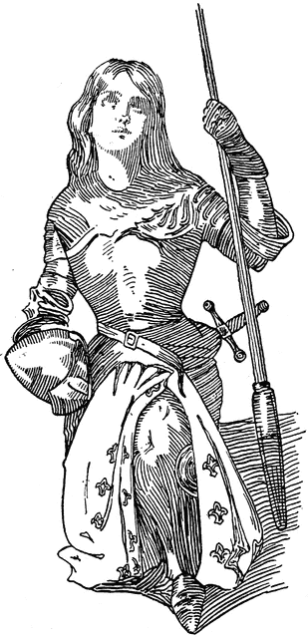Choose one individual from the list provided:

* **Charlemagne (Charles the Great)**
* **Joan of Arc**
* 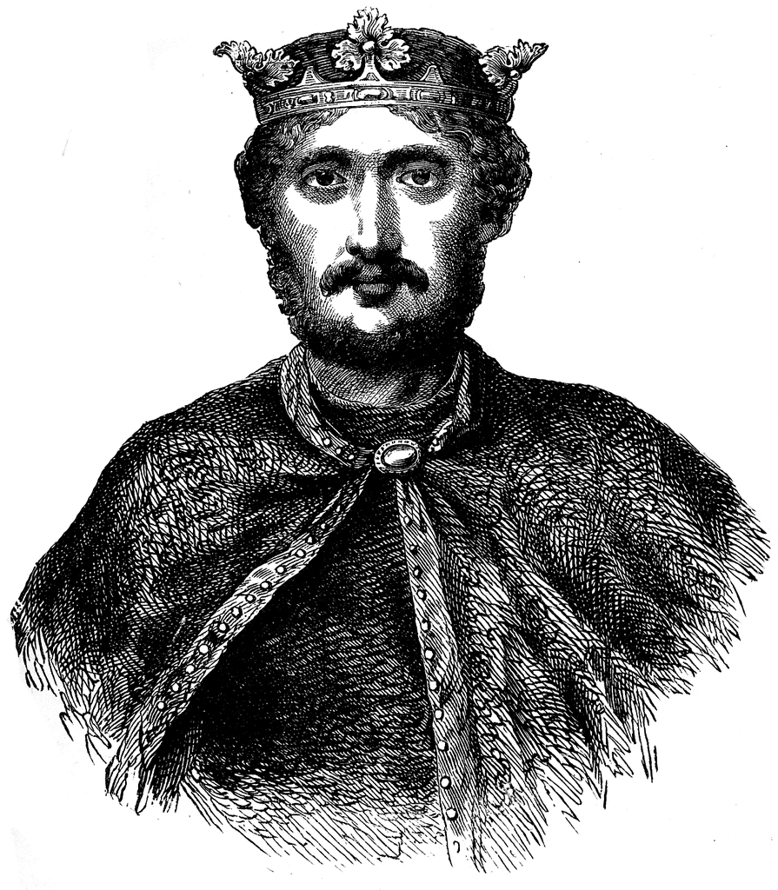**William of Normandy**
* 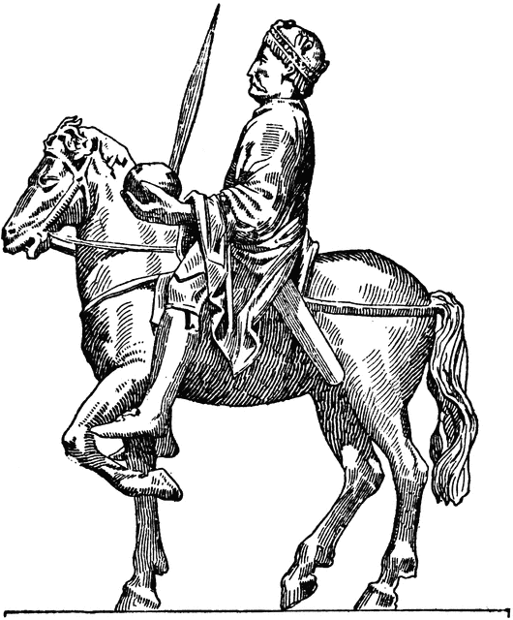**Richard the Lionheart**
* **Eleanor of Aquitaine**
* **Lief Ericson**
* **William Wallace**
* **Geoffrey Chaucer**
* **Johann Gutenberg**
* **Vlad the Impaler**
* **Leonardo DaVinci**

You will:

* Complete the inquiry booklet to record your information. You should use both class time and homework time out of school to complete this assessment.
* Create a museum display (model, poster etc) to communicate your findings. IMPORTANT: you must provide written information about your significant individual with your museum display, the purpose of the display is to be informative and communicate your research findings. You will need to complete the bibliography and submit this with your museum display.
* Complete an in-class validation. This will be in the form of a scaffolded essay.

Part B: Museum Display (72 marks)

Present your findings as a museum display which will be conducted in class, in four lessons, using your inquiry booklet. Plus, you can work on this task for homework.

**The museum display must include:**

* The background of the significant individual (family background, early influences)
* The career of the significant individual (key events in their lives, methods used to achieve aims, relationships with other individuals and groups)
* Challenges to the individual presented by others
* Manner and impact of their death
* The legacy of the significant individual (assessment of their life and career, ways they shaped or changed their society, their long-term impact and legacy).

**KWL (6 marks)**

|  |  |  |
| --- | --- | --- |
| **What do you KNOW?** | **What do you WANT to know?** | **What have you LEARNED?** |
|  |  |  |

**Notetaking: use the focus questions to find information about significant individual.** Add paper if required.

|  |  |
| --- | --- |
| Focus question 1: | Focus question 2: |
|  |  |

|  |  |
| --- | --- |
| Focus question 3: | Focus question 4: |
|  |  |

|  |  |
| --- | --- |
| Focus question 5: | Focus question 6: |
|  |  |

**Reflection**   **(6 marks)**

Please respond to the following four questions (*be specific)*:

I learnt …

|  |
| --- |
|  |
|  |
|  |
|  |
|  |
|  |

I was surprised …

|  |
| --- |
|  |
|  |
|  |
|  |
|  |
|  |

I wonder …

|  |
| --- |
|  |
|  |
|  |
|  |
|  |
|  |

**Bibliography – to be submitted with your museum display (6 marks)**

*Bibliography – a list of all the source you have referred to throughout your inquiry.*

You need to create a correctly formatted bibliography for any inquiry that you do. Record all the details of every source you access in your bibliography.

The rule is – **if you SIGHT it – CITE it!**

*Plagiarism – the practice of taking someone else’s work or ideas and passing them off as one’s own***.**

Narrogin Senior High School has a ZERO TOLERANCE POLICY regarding plagiarism.

**citethisforme.com** is a usual website for compiling references**.**

**Books**

**Example**: Arends, K. Humanities & Social Sciences 8, Pearson, 2017.

|  |  |  |  |  |
| --- | --- | --- | --- | --- |
| Author’s Surname | Author’s First name | (Year Published) | *Book Title (in Italics)* | Place of Publication: Book Publisher. |
| , | . | . | . | . |

**Websites**

**Example:** Cowley, R. Saladin, from the Readers Companion to Military History, 1996, <https://www.history.com/topics/saladin>, accessed 31/7/18

|  |  |  |  |  |  |
| --- | --- | --- | --- | --- | --- |
| Author’s Surname | Author’s First name | (Year Published) | *Website Title (In Italics)* | Website URL | Date you used the website. |
| , | . | . | . | . | Accessed: |

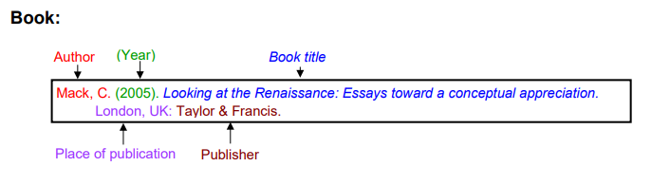Once you have created your reference, all references are organised on a new page in ALPHABETICAL order by the author’s surname.

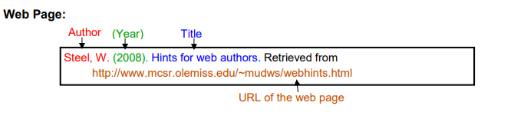

**Year 8 – History – Significant Individual from Medieval Europe (Inquiry Task) DETAILED MARKING GUIDE/RUBRIC - PART A: INQUIRY BOOKLET (4%)**

|  |  |  |  |  |  |  |  |
| --- | --- | --- | --- | --- | --- | --- | --- |
| **Task 🡫 &**  **Marks Allocation 🡪** | **1 - 2** | | | **3 - 4** | **5 - 6** | **7 - 8** | **Subtotal** |
| **KWL** | Presents a KWL which lacks detail and shows limited prior knowledge on the chosen topic. | | | Presents a detailed KWL which clearly outlines prior knowledge on the chosen topic. | Presents a very detailed and comprehensive KWL which clearly outlines prior knowledge on the chosen topic. |  |  |
| **Notetaking**  **Background Information** | Provides limited and/ or no notes for background information of the significant individual.  Does not complete this section. | | | Provides basic points notes that may or may not address the focus research area Background information of the Significant individual. Addresses research areas in limited detail. . | Provides generalised notes that address Background information of the Significant individual. Addresses research areas in some detail. Has constructed full sentences from key points though not always correctly. | Provides very detailed, comprehensive and accurate notes that Background information of the Significant individual. Notes address research areas in detail and has changed key points into full sentences effectively. Uses evidence from a range of sources. |  |
| **Notetaking**  **Role/career of the Significant individual** | Provides limited and/ or no notes for role/career of the Significant individual.  Does not complete this section. | | | Provides basic points notes that may or may not address the focus research area role/career of the significant individual in society. Addresses research areas in limited detail. . | Provides generalised notes that address role/career of the significant individual in society. Addresses research areas in some detail. Has constructed full sentences from key points though not always correctly. | Provides very detailed, comprehensive and accurate notes that addresses role/career of the significant individual in society. Notes address research areas in detail and has changed key points into full sentences effectively.  Uses evidence from a range of sources. |  |
| **Notetaking**  **Challenges** | Provides limited and/ or no notes for on the challenges that chosen individual faced  Does not complete this section. | | | Provides basic points notes that may or may not address on the challenges that chosen individual faced. Addresses research areas in limited detail. . | Provides generalised notes that address the challenges that chosen individual faced. Addresses research areas in some detail. Has constructed full sentences from key points though not always correctly. | Provides very detailed, comprehensive and accurate notes that addresses the challenges that chosen individual faced. Notes address research areas in detail and has changed key points into full sentences effectively. Uses evidence from a range of sources. |  |
| **Notetaking**  **Manner and Impact of Death** | Provides limited and/ or no notes about the manner and impact of the death of the significant individual  Does not complete this section. | | | Provides basic points notes that may or may not address the manner and impact of the death of the significant individual. Addresses research areas in limited detail. . | Provides generalised notes that addresses the manner and impact of the death of the significant individual. Addresses research areas in some detail. Has constructed full sentences from key points though not always correctly. | Provides very detailed, comprehensive and accurate notes that addresses the manner and impact of the death of the significant individual.  Notes address research areas in detail and has changed key points into full sentences effectively. Uses evidence from a range of sources. |  |
| **Notetaking**  **Legacy** | Provides limited and/ or no notes for legacy of the significant individual  Does not complete this section. | | | Provides basic points notes that may or may not address the focus research area legacy of the significant individual. Addresses research areas in limited detail. . | Provides generalised notes that address legacy of the significant individual. Addresses research areas in some detail. Has constructed full sentences from key points though not always correctly. | Provides very detailed, comprehensive and accurate notes that addresses legacy of the significant individual. Notes address research areas in detail and has changed key points into full sentences effectively. Uses evidence from a range of sources. |  |
| **Reflection** | Does not complete all sections of the self-reflection.  No self –reflection submitted(0) | | | Completes parts of the self-reflection using full sentences and uses some detailed examples. | Completes parts of the self-reflection using full sentences and uses some detailed examples. |  |  |
|  |  |  |  | | | | **/52** |

**Year 8 – History – Significant Individual from Medieval Europe (Inquiry Task) DETAILED MARKING GUIDE/RUBRIC - PART B: MUSEUM DISPLAY (3.5%)**

|  |  |  |  |  |  |
| --- | --- | --- | --- | --- | --- |
| **Task 🡫 &**  **Marks Allocation 🡪** | **8 - 10** | **5 - 7** | **2 - 4** | **0 - 2** | **Subtotal** |
| **Background** | Provides a very detailed description on the background of the chosen individual. The description includes all of the following areas; date of birth, place of birth, parents and early influences. | Provides a detailed description on the background of the chosen individual. The description includes information on most of the following areas; date of birth, place of birth, parents and early influences. | Has briefly outlined the background of the chosen individual. The description includes information on some of the following areas; date of birth, place of birth, parents and early influences. | Has provided little or no description of the background of the chosen individual. |  |
| **Career** | Provides a very detailed description on the career of the chosen individual. The description addresses all of the following areas; key events, methods used to achieve aims, relationships with other individuals. | Provides a detailed description on the career of the chosen individual. The description addresses most of the following areas; key events, methods used to achieve aims, relationships with other individuals. | Has briefly outlined the career of the chosen individual. The description addresses some of the following areas; key events, methods used to achieve aims, relationships with other individuals. | Has provided little or no description of the career of the chosen individual. |  |
| **Challenges** | Provides a very detailed description on the challenges that chosen individual faced. | Provides a detailed description on the challenges that the chosen individual faced. | Has briefly outlined the challenges which the chosen individual faced. | Has provided little or no description of the challenges which the chosen individual faced. |  |
| **Manner and Impact of Death** | Provides a very detailed description on the manner and impact of the chosen individual’s death. | Provides a detailed description on the manner and impact of the chosen individuals death. | Has briefly outlined the manner and impact of the chosen individuals death. | Has provided little or no description of the manner and impact of the chosen individuals death. |  |
| **Legacy** | Provides a very detailed description on the legacy of the chosen individual. This description includes an assessment of the individual’s life and career and how they impacted society. | Provides a detailed description on the legacy of the chosen individual. This description includes a brief summary of the individual’s life and career and how they impacted society. | Has briefly outlined the legacy of the chosen individual. The description makes some mention to how they individual shaped society although it may historically incorrect. | Has provided little or no description of the legacy of the chosen individual. |  |
|  | **5 - 6** | **3 - 4** | **1 - 2** | **0** |  |
| **Use of examples/supporting evidence** | Has selected supporting evidence/examples that effectively reinforce the written description of life and legacy of the chosen individual. | Has selected supporting evidence/examples that mostly reinforces the written description of the chosen individual. | Has selected a narrow range of supporting evidence/examples that do not necessarily reinforce the written description of the chosen individual. | Has not provided any supporting evidence/ examples. |  |
|  | **6 - 8** | | **3 -5** | **0 - 2** |  |
| **Presentation-Visual** | Presentation is visually engaging. Displays a high level of detail and presents information about the significant individual to a high standard. It is clear that a lot of time and thought is put into the presentation. | | Presentation is engaging. Displays a satisfactory level of detail and overall presents information about the significant individual to satisfactory standard. Some time and thought is put into the presentation. | Presentation is somewhat engaging. Displays limited amount of detail and presents little information about the significant individual. Little time or thought is put into the presentation. |  |
| **Bibliography** | Collects information and images from a comprehensive number of sources and records a variety of key information which relates to the chosen significant individual, incorporating ethical protocols, which correctly follow the referencing technique approved by the school. | | Bibliography includes a smaller range of sources which mostly follows the referencing technique approved by the school. | No bibliography submitted (0)  Bibliography includes a limited list of sources which may follow the referencing technique approved by the school, however, does not incorporate all requirements. |  |
| **Task 3 - TOTAL** | **/72** |

**Overall comment:**

What you did well…

*__________________________________________________________________________________________________________________________________________________________________________________________________________________________________________________________________*

The best part was…

*__________________________________________________________________________________________________________________________________________________________________________________________________________________________________________________________________*

Even better if…

*__________________________________________________________________________________________________________________________________________________________________________________________________________________________________________________________________*